Axel Oliver

Nathan Chaimongkhon

20069301

J222144

TECHNICAL REQUIREMENTS FOR Wayfinder APPLICATION

Wayfinder APp

technical requirements for Wayfinder application

dIPLOMA OF SOFTWARE DEVELOPMENT

Wayfinder APP

# business requirements

## purpose

The purpose of the Wayfinder App is to allow students to easily navigate through TAFE buildings and find their classes and events within campus.

## MODEL OF BUSINESS

The Wayfinder app will be targeted at TAFE students and staff to allow them to navigate through campus. The Wayfinder App will be a free to use service, funded by TAFE.

## Stakeholders

TAFE.

## requirements

|  |  |
| --- | --- |
| Functional | Non Functional |
| Allow every student to login to an account or Register | * Login will be secure, using a HTTP Post Method * Passwords will be encrypted using hashing. |
| Display interior map of TAFE buldings | * User can easily navigate the map by dragging or scrolling for zoom * Show building number and room numbers inside each building |
| Will be available on both mobile and desktop devices of varying screen sizes | * Responsive front end design based on screen size |
| Admins would be able to edit users | * Admins will have CRUD functionality for users |
| Profile Page | * Allow users to edit or delete their profile |
| Bug submission page | * Allow a user to click “report a bug” which will take them to a page and enter details about a bug |
| Events Page | * Allow a user to click an event which will take them to the map page with directions to that event |

## user INTERFACES

What information and features does the GUI (Graphical User Interface) need to provide to the end users?

The GUI of the Stubby website will need the following pages:

* Login Page

The user needs to be able to see a button to sign up or enter their details to login.

* Profile page

The user needs to be able to see their profile and options to edit details such as changing password or deactivating their account.

* Map Page

The user needs to be able to navigate a map which shows the interior layout of TAFE buildings, as well as room and building numbers.

* Event Page

The user needs to be able to browse a list of events, which each event linking to the map page with a pin on the event location.

* Bug Report Page

The user will be able to report bugs, this will include details such as:

* + - How to reproduce the bug
    - Details of the bug
    - What they were doing when the bug occured

The Wayfinder app will provide web API services to display information about events on campus in JSON format. An API request should display all events or be able to request events in between a specified time-frame.

# technical REQUIREMENTS

## hardware

During development of the Wayfinder App, developers will use their desktop running on a Windows environment. Developers will be required to have suitable storage space and processing power to test and run the mock database locally before deployment as well as all Laravel development tools installed.

The Wayfinder app will be hosted by AWS, using their servers and other hardware for deployment of the application. AWS uses intel Xeon processors and often holds 11petabytes of data on a standard 42U rack, and will run on an ubuntu OS. AWS also has custom built routers optimized for their service.

The Hardware required for users of the Wayfinder application will be anything with access to an internet browser, such as mobile or desktop.

## software

Database language will be MySQL and management will be done using PhpMyAdmin during development, and DynamoDB during deployment (offered by AWS). Development of the Wayfinder App will be accomplished using Visual Studio IDE with Xamarin. Xamarin will be used to develop the GUI of the mobile app. Developers are using Xamarin due to preference of the C# language.

## NETWORK REQUIREMENTS

Internet access will be required to access the Wayfinder application as it is a mobile application that requires internet access. It will be a single user experience as users will not be interacting directly with each other. There will be installation components required to use the app on mobile.

## TECHNOLOGY OPTIONS CONSIDERED

AWS will be used for the database component of the application. User information and event information will be stored on the database.

Google Maps will be used to display and navigate the layouts of the TAFE buildings. The reason for using Google Maps is ease of use and development.

Git will be used for source control. Developers will need to use Git as the development process will be mostly remote, and Git will allow all developers to implement features without breaking other changes being made by other developers. Using a shared network for this project to sync development files more quickly would be good, however is not viable due to the remote nature of the development team.

The application will be developed locally with Git version control. Migrations and seeds to databases will ensure developers work with a consistent database and must have MySQL installed on their machine. Local machine development is most practical as work will be mostly remote and developers will not have access to a shared server.

Another option would be privately hosting the application on AWS until ready for deployment, but as the team aims to save as much as possible on maintenance and operation costs, integration into AWS will be delayed for as long as possible.

# technical solution

## Proposed solution

AWS(Amazon Web Services) provide a platform with already built infrastructures for the application. The Platform will remove the cost of setting up our infrastructures such as servers, database and networks. AWS also provide a student account that is valid for one year. With this, the team can host the website free of charge. The student account provides; an excellent solution for hosting the application.

Google Maps will be used as the navigation system because it has a large amount of online resources and support, there is also functionality that allows developers to implement their own interior maps.

## technical specifications

1. The data structure for the Wayfinder app database will only contain a user table to allow logins, or registrations of users.

The Application design will implement the Model-View-Controller design pattern. The model will be the medium between the view and the controller to ensure relevant data is parsed between the two and the view is updated accurately for the user to see.

## SECURITY

* Database user roles security

Database role security will required as users of the application only need limited access to the database on their own personal account, however database administrators will have the ability to edit, add, or delete all user accounts if necessary. This will ensure that a user with any malicious intent will not be able to access database fields that may compromise any privacy or break database structure.

* Registered Users

Registered users will be able to browse events and edit/deactivate their account, and have access to the events table so they can view events.

* Saving audit trails of changes

Audit trials can be recorded by creating a table for each existing table in the database to record any changes made to the original table. Database triggers will be used and the user, time, and change will be recorded. Role security will be tight on the table to ensure any database users cannot disable the change table, make a change, then enable it again other than administrators.

* Encryption for storage and transmission of sensitive data, such as passwords.

The Laravel Hash facade provides secure Bcrypt and Argon2 hashing for storing user passwords. Bcrypt will be used for registration and authentication by default.

* Program security such as preventing SQL Injection attacks

The Laravel query builder uses PDO parameter binding to protect your application against SQL injection attacks. There is no need to clean strings being passed as bindings.

* Network infrastructure security, such as firewalls and anti-virus software

AWS provides network infrastructure and security including network inspection, data protection and encryption, logging, monitoring, threat detection, analytics and more.

## COPYRIGHT AND IP

In Australia, copyright law is governed by the Copyright Act 1968. The owner of copyright in software has the exclusive right to:

* make copies of the software
* publish the software
* communicate the software to the public
* make adaptations of the software
* enter into a commercial rental arrangement with respect to the software
* license others to do any of the above.

The license agreement of the Stubby App will determine the actions users can and cannot make regarding the IP of the software.

# implementation plan

## RESOURCES AND TIMELINES

The Wayfinder app will be developed by a 2 man team, and a Kanban board will be used to manage development. Each team member will have access to a computer.

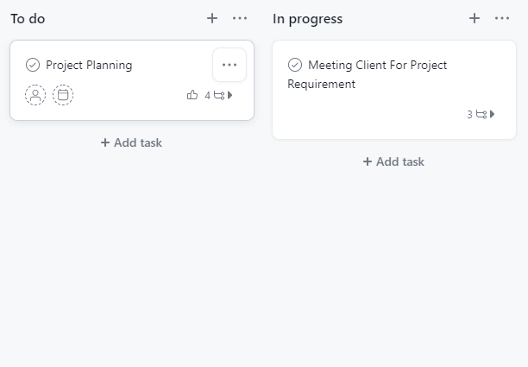

## COSTS OF IMPLEMENTATION

Budget Estimation

|  |  |  |  |
| --- | --- | --- | --- |
|  | **Cost** | **Amount** | **Total** |
| **Hardware** | - | - | $0 |
| **Man Hours** | $45/hr | 10 weeks * 2 =  400hrs * 2 | $36000 |

## impact of change

The Wayfinder app will allow a user to easily find and navigate through a TAFE campus to their desired class or building.

## TRAINING NEEDS

1. The application will be very straightforward with tooltips and other indicators that will help guide users on how to use the software, so training will not be required for users to be able to use the software effectively.

There will also be a tutorial document with FAQ for users.

## PERFORMANCE benchmarkS

Load testing will be performed on the database to ensure a response time under 500ms is achieved in queries.

## validation and signoff

After the project has been completed, a meeting with the client will be done outlining all requested features and the outcome of development. The client will sign off a contract signaling the agreement has been completed and may request further development.